Cover Page  LOT # 08813 | 16X20X48 R6  PLENUM RAW/END CAP  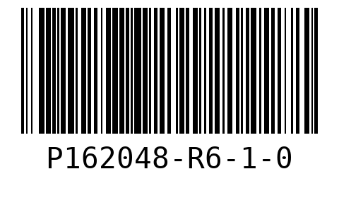  WO 147024  LOT 08813  QTY 20
20X20X48 R6  PLENUM RAW/END CAP  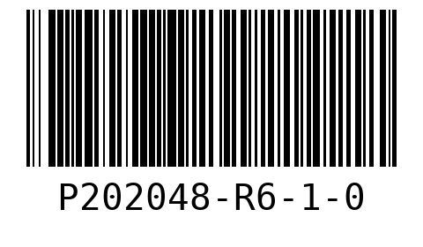  WO 147031  LOT 08813  QTY 20 | 20X20X48 R6  PLENUM RAW/END CAP  WO 147041  LOT 08813  QTY 20

Sheet # 1  LOT # 08813 | 16X20X48 R6  PLENUM RAW/END CAP  WO 147024  LOT 08813
16X20X48 R6  PLENUM RAW/END CAP  WO 147024  LOT 08813 | 16X20X48 R6  PLENUM RAW/END CAP  WO 147024  LOT 08813
16X20X48 R6  PLENUM RAW/END CAP  WO 147024  LOT 08813 | 16X20X48 R6  PLENUM RAW/END CAP  WO 147024  LOT 08813
16X20X48 R6  PLENUM RAW/END CAP  WO 147024  LOT 08813 | 16X20X48 R6  PLENUM RAW/END CAP  WO 147024  LOT 08813
16X20X48 R6  PLENUM RAW/END CAP  WO 147024  LOT 08813 | 16X20X48 R6  PLENUM RAW/END CAP  WO 147024  LOT 08813
16X20X48 R6  PLENUM RAW/END CAP  WO 147024  LOT 08813 | Sheet # 2  LOT # 08813

16X20X48 R6  PLENUM RAW/END CAP  WO 147024  LOT 08813 | 16X20X48 R6  PLENUM RAW/END CAP  WO 147024  LOT 08813
16X20X48 R6  PLENUM RAW/END CAP  WO 147024  LOT 08813 | 16X20X48 R6  PLENUM RAW/END CAP  WO 147024  LOT 08813
16X20X48 R6  PLENUM RAW/END CAP  WO 147024  LOT 08813 | 16X20X48 R6  PLENUM RAW/END CAP  WO 147024  LOT 08813
16X20X48 R6  PLENUM RAW/END CAP  WO 147024  LOT 08813 | 16X20X48 R6  PLENUM RAW/END CAP  WO 147024  LOT 08813
16X20X48 R6  PLENUM RAW/END CAP  WO 147024  LOT 08813 | 16X20X48 R6  PLENUM RAW/END CAP  WO 147024  LOT 08813
Sheet # 3  LOT # 08813 | 20X20X48 R6  PLENUM RAW/END CAP  WO 147031  LOT 08813

20X20X48 R6  PLENUM RAW/END CAP  WO 147031  LOT 08813 | 20X20X48 R6  PLENUM RAW/END CAP  WO 147031  LOT 08813
20X20X48 R6  PLENUM RAW/END CAP  WO 147031  LOT 08813 | 20X20X48 R6  PLENUM RAW/END CAP  WO 147031  LOT 08813
20X20X48 R6  PLENUM RAW/END CAP  WO 147031  LOT 08813 | 20X20X48 R6  PLENUM RAW/END CAP  WO 147031  LOT 08813
20X20X48 R6  PLENUM RAW/END CAP  WO 147031  LOT 08813 | 20X20X48 R6  PLENUM RAW/END CAP  WO 147031  LOT 08813
20X20X48 R6  PLENUM RAW/END CAP  WO 147031  LOT 08813 | Sheet # 4  LOT # 08813
20X20X48 R6  PLENUM RAW/END CAP  WO 147031  LOT 08813 | 20X20X48 R6  PLENUM RAW/END CAP  WO 147031  LOT 08813

20X20X48 R6  PLENUM RAW/END CAP  WO 147031  LOT 08813 | 20X20X48 R6  PLENUM RAW/END CAP  WO 147031  LOT 08813
20X20X48 R6  PLENUM RAW/END CAP  WO 147031  LOT 08813 | 20X20X48 R6  PLENUM RAW/END CAP  WO 147031  LOT 08813
20X20X48 R6  PLENUM RAW/END CAP  WO 147031  LOT 08813 | 20X20X48 R6  PLENUM RAW/END CAP  WO 147031  LOT 08813
20X20X48 R6  PLENUM RAW/END CAP  WO 147031  LOT 08813 | 20X20X48 R6  PLENUM RAW/END CAP  WO 147031  LOT 08813
Sheet # 5  LOT # 08813 | 20X20X48 R6  PLENUM RAW/END CAP  WO 147041  LOT 08813
20X20X48 R6  PLENUM RAW/END CAP  WO 147041  LOT 08813 | 20X20X48 R6  PLENUM RAW/END CAP  WO 147041  LOT 08813

20X20X48 R6  PLENUM RAW/END CAP  WO 147041  LOT 08813 | 20X20X48 R6  PLENUM RAW/END CAP  WO 147041  LOT 08813
20X20X48 R6  PLENUM RAW/END CAP  WO 147041  LOT 08813 | 20X20X48 R6  PLENUM RAW/END CAP  WO 147041  LOT 08813
20X20X48 R6  PLENUM RAW/END CAP  WO 147041  LOT 08813 | 20X20X48 R6  PLENUM RAW/END CAP  WO 147041  LOT 08813
20X20X48 R6  PLENUM RAW/END CAP  WO 147041  LOT 08813 | Sheet # 6  LOT # 08813
20X20X48 R6  PLENUM RAW/END CAP  WO 147041  LOT 08813 | 20X20X48 R6  PLENUM RAW/END CAP  WO 147041  LOT 08813
20X20X48 R6  PLENUM RAW/END CAP  WO 147041  LOT 08813 | 20X20X48 R6  PLENUM RAW/END CAP  WO 147041  LOT 08813

20X20X48 R6  PLENUM RAW/END CAP  WO 147041  LOT 08813 | 20X20X48 R6  PLENUM RAW/END CAP  WO 147041  LOT 08813
20X20X48 R6  PLENUM RAW/END CAP  WO 147041  LOT 08813 | 20X20X48 R6  PLENUM RAW/END CAP  WO 147041  LOT 08813
20X20X48 R6  PLENUM RAW/END CAP  WO 147041  LOT 08813 | 20X20X48 R6  PLENUM RAW/END CAP  WO 147041  LOT 08813

